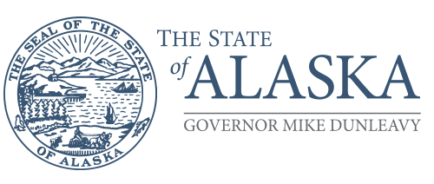
Department of Family
and Community Services

Office of Children’s Services
Director’s Office

P.O. Box 112631
Juneau, Alaska 99811-2631
Main: 907.465.3191
Fax: 907.465.3397

REQUEST FOR INTERVIEW - CHILD ABUSE OR NEGLECT

This form is to be used by Department of Family and Community Services personnel when requesting authority to interview a student at school. As required by AS 47.17.027(a), the Alaska Department of Health and Social Services (DHSS) is to provide written certification of the following:

On behalf of DFCS, I formally request that the ______ School District make available to me,

 | on
Name of Child |  | Date

for the purpose of conducting an interview of said child at school in furtherance of a child abuse or neglect investigation by DFCS pursuant to AS 47.17.027.

The school district may not inform the parent(s) of said child of the interview prior to the interview occurring, Immediately after conducting an interview and after informing the child of the intention to notify the child’s parent(s) or guardian, DFCS shall make every reasonable effort to notify the child’s parent(s) or guardian that the interview occurred unless it is determined the notification would endanger the child.

I affirm that (1) there is reasonable cause to suspect that the child has been abused or neglected by a person responsible for the child’s welfare, or (2) as a result of conditions created by a person responsible for the child’s welfare, an interview at school is a necessary part of the investigation to determine whether the child was abused or neglected, and (3) the interview at school is in the best interest of the child.

A school official shall or shall not be present during the interview. [Alaska Statute 47.17.027(a)].

If a school official cannot be present during the interview, it is because
the child objects or
DFCS determines that the presence of the school official will interfere with the investigation.

This child is being placed in the custody of the State Of Alaska. [Alaska Statute 47.10 Child in Need of Aid, Alaska Statute 47.17 Child Protection]
The Office of Children's Services will contact the parents regarding this action.

Worker’s Name |  | Title |  | Phone

